Ex:No: 14

Date:

**TCL COMMANDS – COMMIT, SAVEPOINT, ROLLBACK**

**Aim:**

To learn how to use various TCL commands Commit, Savepoint and Rollback SQL commands

**Procedure and Syntax:**

Transaction Control Language(TCL) commands are used to manage transactions in the database. These are used to manage the changes made to the data in a table by DML statements. It also allows statements to be grouped together into logical transactions.

**COMMIT:**

* COMMIT command is used to permanently save any transaction into the database.
* When we use any DML command like INSERT, UPDATE or DELETE, the changes made by these commands are not permanent, until the current session is closed, the changes made by these commands can be rolled back.
* To avoid that, we use the COMMIT command to mark the changes as permanent

**Syntax:**

COMMIT;

**ROLLBACK:**

* This command restores the database to last committed state.
* It is also used with SAVEPOINT command to jump to a savepoint in an ongoing transaction.
* If we have used the UPDATE command to make some changes into the database, and realize that those changes were not required, then we can use the ROLLBACK command to rollback those changes, if they were not committed using the COMMIT command.

**Syntax:**

ROLLBACK;

ROLLBACK TO savepoint_name;

**SAVEPOINT:**

* SAVEPOINT command is used to temporarily save a transaction so that you can rollback to that point whenever required.

**Syntax:**

SAVEPOINT savepoint_name;

**Problem 1:**

Create a following table Class and insert values into it in the following order and create savepoints in between them. Try to rollback the save point and check your output by giving select commands.

**Let us use some SQL queries on the above table and see the results.**

UPDATE class SET name ='bravo' WHERE id ='5';

SAVEPOINT A;

INSERT INTO class VALUES('uppal', 6);

SAVEPOINT B;

INSERTINTO class VALUES(‘balu’, 7);

SAVEPOINT C;

Now let's use the ROLLBACK command to roll back the state of data to the savepoint.

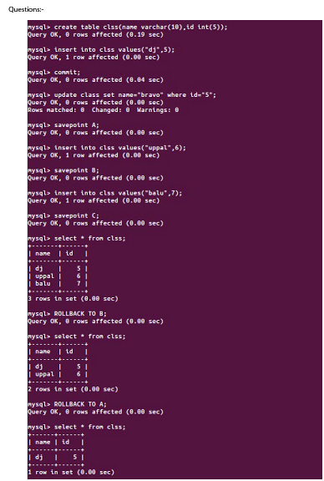

**Result:**

The commands SQL COMMIT, ROLLBACK and SAVEPOINT are implemented and result is verified.